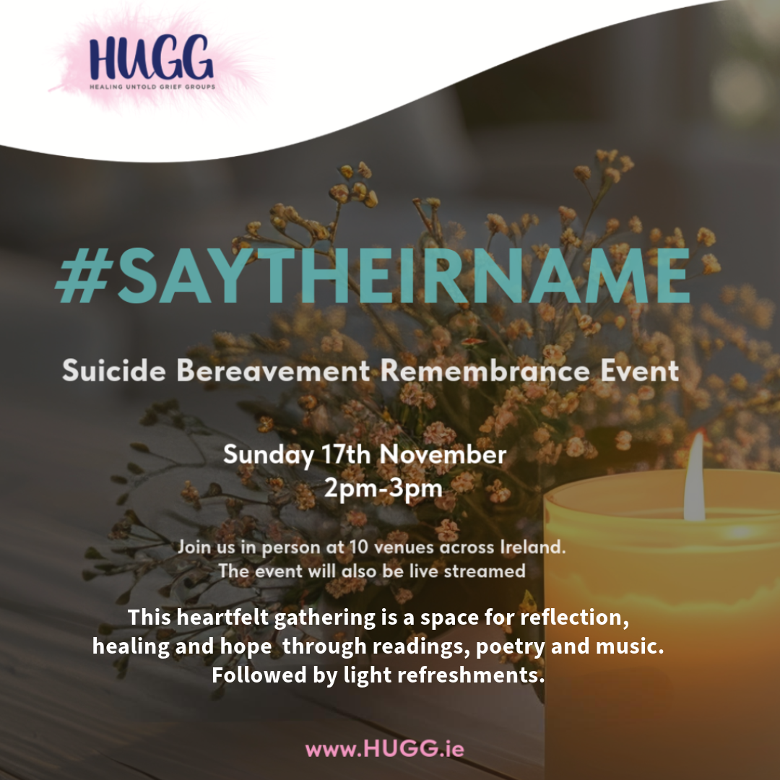
Each year in mid-November, people who are bereaved by suicide come together globally to honour the memory of those who have died by suicide. As Ireland's national suicide bereavement charity, HUGG is inviting the public to join them for a remembrance event.
📅 Date: Sunday, 17th November
🕑 Time: 2-3 pm (doors open at 1:45 pm)
📍 Location: Unitarian Church, Dublin (Stephen’s Green, D02 YP23) & streamed live
In addition to the Dublin event, HUGG volunteers will host local gatherings in several locations across Ireland, where people can come together to watch the live stream✨ Additional Locations
- Buncrana: Inishowen Gateway Hotel, F93 PPH9
- Cavan: Hotel Kilmore, H12 F6Y7
- Cork: Clayton Hotel Silver Springs, T12 RD6E
- Galway: Clayton Hotel, H91 D526
- Kildare: Osprey Hotel, W91 X40K
- Limerick: Maldron Hotel, V94 EDP4
- Louth: The Gateway Hotel, A91 EF88
- Monaghan: Westenra Arms, H18 XA97
- Waterford: Viking Hotel, X91 Y657
No registration required. If you can’t join in person you can watch the live stream from anywhere: https://bit.ly/SayTheirName2024
#SayTheirName #HUGG #SuicideBereavement

