
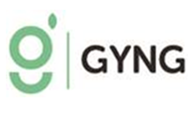

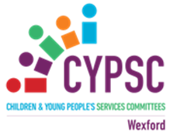

Wexford Girls Get Active 2026

Costings Form – (Please attach with EOI Form)

Please note the maximum amount available per group will be €800.
Item | Description | € Amount
Instructor/Activity Fees
Venue Hire
Total Expenditure

