Wexford Children and Young People’s Services Committee (CYPSC) launches new website

On October 14th 2016. Wexford Children and Young People’s Services Committee (CYPSC) launched its new website in the Riverside Park Hotel, Enniscorthy. The new website, www.wexfordcypsc.ie brings together information on a range of services available for children, young people and families in Wexford, including mental health support for children and young people; health services for children, young people and families; education and training opportunities; and help and support for families.

The new website also features an interactive map of services in County Wexford to help children, young people and their families find out how and where they can access the help and support that they need.

Speaking at the launch, Dr John Sharry, social worker, child and family psychotherapist and columnist with The Irish Times, said “Frequently, parents and young people who are dealing with challenges do not know how to access support and often cannot find a service suitable for them in their local area. This new Wexford website is a great local resource to point families in the direction of quality services and supports in Wexford.”

The launch was attended by professionals who work with children, young people and families in Wexford as well as representatives from organisations involved in Wexford CYPSC.

The website was launched by Ms Colma Nic Lughadha, National Co-ordinator for Children and Young People’s Services Committees, who said: “I am delighted to launch this new Wexford CYPSC website today. It is a very welcome resource and one-stop shop for the children, young people and families of County Wexford to find the help, support and services they need. The overall purpose of Children and Young People’s Services Committees is to ensure better outcomes for children and young people around the country through enhanced co-ordination of local services and organisations. This new website is an example of this co-ordination in action and is an important step towards improving service provision for the benefit of children, young people and families in County Wexford.”

Please see next page for some pictures from the event.

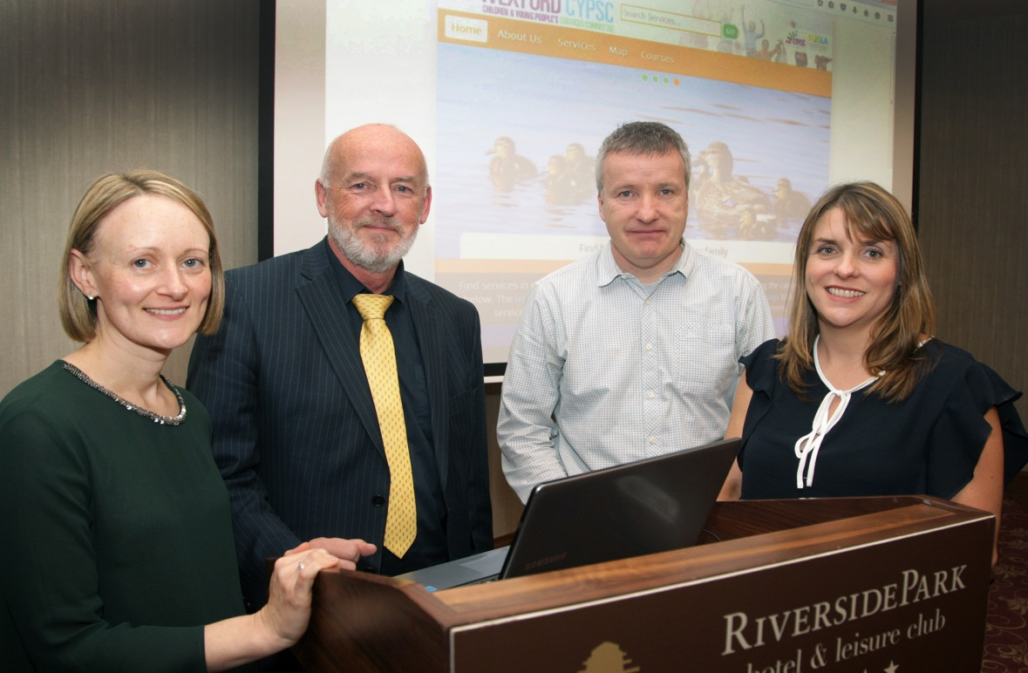
Above (L-R);
At the launch of www.wexfordcypsc.ie on October 14th 2016 were;
Sheila Barrett (Co-ordinator, Wexford CYPSC), Vincent Daly (Chairperson, Wexford CYPSC), Dr. John Sharry (Keynote Speaker), Colma Nic Lughadha (National Co-ordinator for Children and Young Peoples Services Committees).

Below (L-R);
Anne Marie Costello (Youth New Ross and member of Information & Resources Working Group), David O Farrell (Website Developer), Dearbhla Ni Laighin (Wexford Co.Co. Library Service and member of Info & Resources Working Group)

