A BROCHURE HAS BEEN PREPARED ON HOW TO GET UKRAINIAN EDUCATION FOR CHILDREN WHO ARE TEMPORARILY STAYING ABROAD

Posted on September 1, 2022, at 1.50 p.m
The author of the photo is the Office of the Deputy Prime Minister for European and Euro-Atlantic Integration
The Office of the Deputy Prime Minister for European and Euro-Atlantic Integration, in cooperation with the Ministry of Education and Science, have prepared a brochure on the organization of education for children who are temporarily staying with their families abroad and wish to continue their Ukrainian education.
Taking into account the fact that in many European countries getting an education at local educational institutions is mandatory, Ukraine offers its citizens various forms of education according to the national program. The educational process can be organized at a convenient time for the student remotely, simultaneously obtaining an education in the host country.

The brochure contains information about educational opportunities for Ukrainian students and teachers abroad, as well as resources with educational materials to which free access is provided. You can download the brochure using the link.
You can also get information about the organization of education abroad through an educational chatbot on the Telegram or Viber platforms.
Please not that 2,400 educational institutions in Ukraine suffered from bombings and shelling, 269 of them were completely destroyed.

Visual Infographic | Translated Text on Infographic
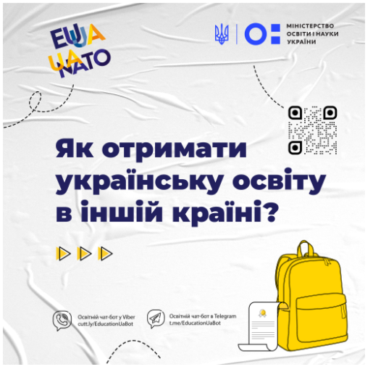 | Ministry of Education and Science of Ukraine  “How to get Ukrainian education in another country?”  Educational chatbot at Viber cutt.ly/EducationUaBot  Educational chatbot at Telegram t.me/EducationUaBot
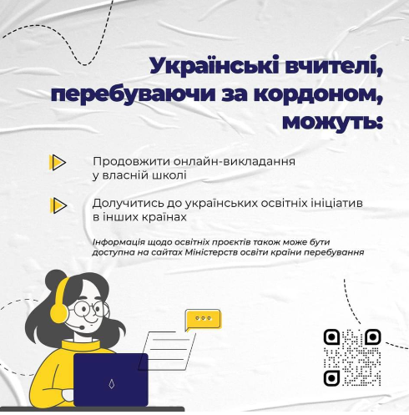 | While being abroad, Ukrainian teachers can:  - Continue online teaching in their own school  - Join Ukrainian educational initiatives in other countries  Information about education projects can also be available on the websites of the Ministries of Education of the host country
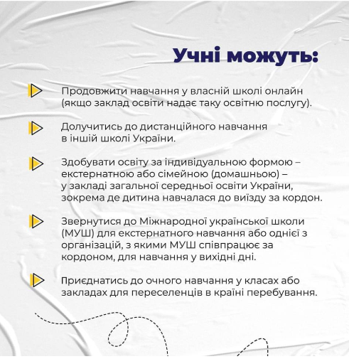 | Students can:  - Continue online studying at their own school (if the educational institution provides such an education service).  - Join distance learning in another school in Ukraine.  - Get an education in an individual form - external or family (home) one - in a general secondary education institution of Ukraine, in particular, where the child had studied before going abroad.  - Contact the International Ukrainian School (IUS) for external study or one of organizations with which IUS cooperates with abroad for studying on weekends.  - Join face-to-face classes or institutions for people temporarily staying abroad in the host country.
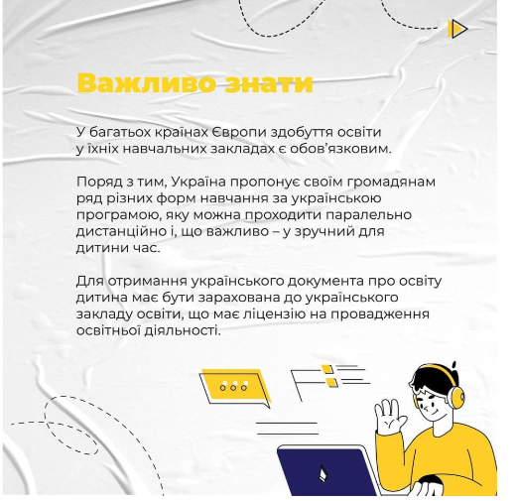 | It’s important to know  Getting education in many European countries in their educational institutions is mandatory.  At the same time, Ukraine offers its citizens a number of different forms of learning according to a Ukrainian program that can be completed simultaneously remotely and, what is important, at a convenient time.  To obtain a Ukrainian education document, the child must be enrolled in a Ukrainian educational institution that has an educational activity license.
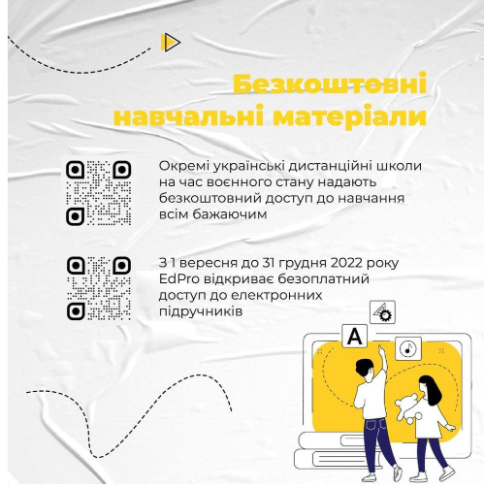 | Free educational materials  During martial law, some Ukrainian distance learning schools provide free access to education to all who wish.  From September 1 to December 31, 2022, EdPro is opening a free access to electronic textbooks.
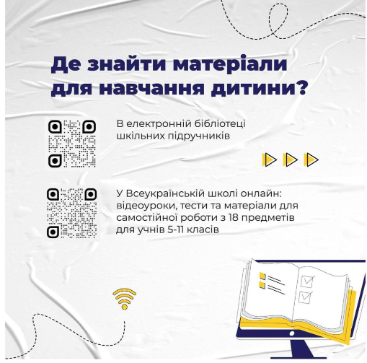 | Where can I find educational materials for my child?  In electronic library of school textbooks  In the All-Ukrainian School online: video lessons, tests and materials for independent work in 18 subjects for students of 5-11 years

