Post 1
National Carers Week (Family Carer’s Ireland)
Event Date: 10-16 June
Post Date: Monday 10th June

Twitter
National Carers Week begins 10th June. @CarersIreland are running events for family carers both online and in person including educational classes, social get-togethers, interactive information sessions, creative workshops and self-care webinars!
https://familycarers.ie/events

Facebook
Throughout the National Carers Week, (week beginning June 10th) Family Carer’s Ireland will be running a wide array of events for family carers both online and in person including educational classes, social get-togethers, interactive information sessions, creative workshops and self-care webinars! For details on all upcoming events for family carers see https://familycarers.ie/events
Post 2
Belongto
Event Date: N/A
Post Date: Friday 7th June

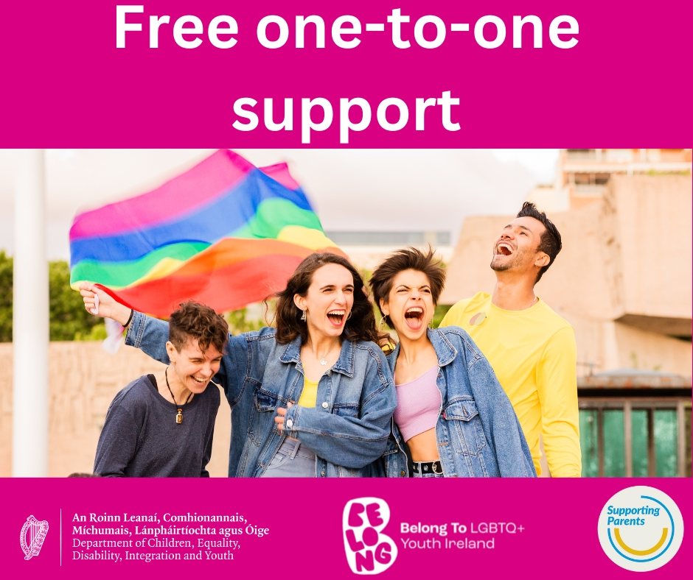

Support for Parents and Families of LGBTQ+ Youth
Belong To’s new Family Support Service offers one-to-one support for the families of LGBTQ+ young people across Ireland
For more info:
Email family@belongto.org
Call 01 670 6223
or Visit www.belongto.org

Post 3
Jigsaw North Fingal
Event Date: 25th June
Post Date: 21st June

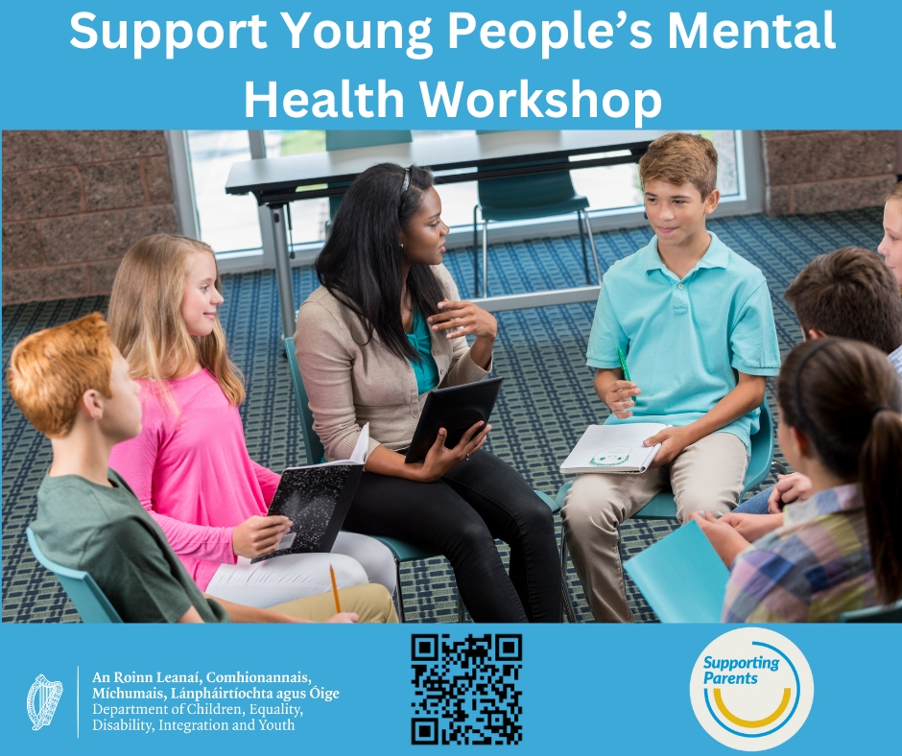

Twitter

Supporting Young People's Mental Health
@JigsawNFingal are hosting an hour long workshop next Tuesday 25th June giving information on promoting and supporting mental health of young people aged 12 to 25 in North Fingal
Register: https://forms.gle/2jG9HgWmBoU9Zgsi9
#SupportingParentsIre

Post 4
Carrigallen Outreach Drop-in Service
Event Date: Every Friday 2024
Post Date: 20/06/2024

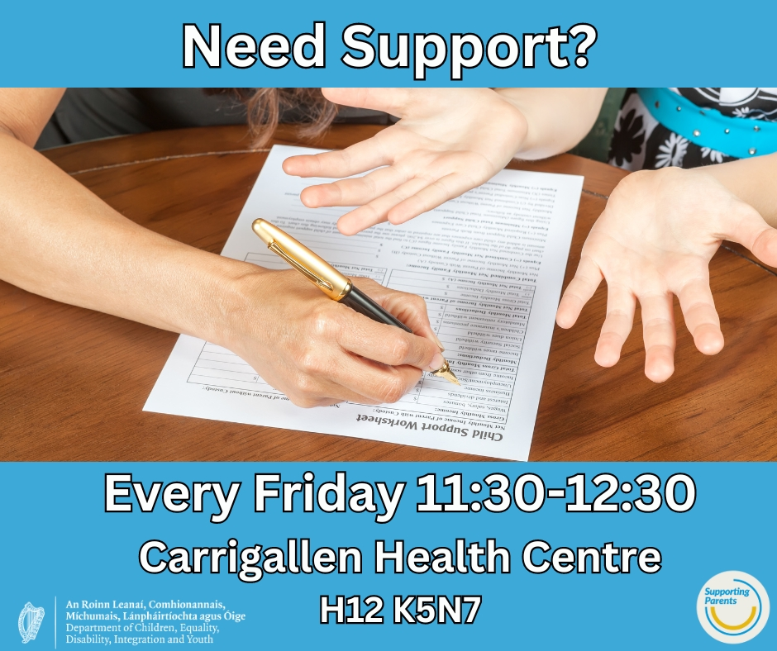

Do you need assistance and support with parenting, completion of forms or need information on these matters?

Talk to our Family Support Worker who will support you through any issues you may be having

Every Friday 11.30-12.30 in Carrigallen Health Centre

#SupportingParentsIre

Post 5
CIH Ireland
Event Date: 19/06/2024
Post Date: 18/06/2024

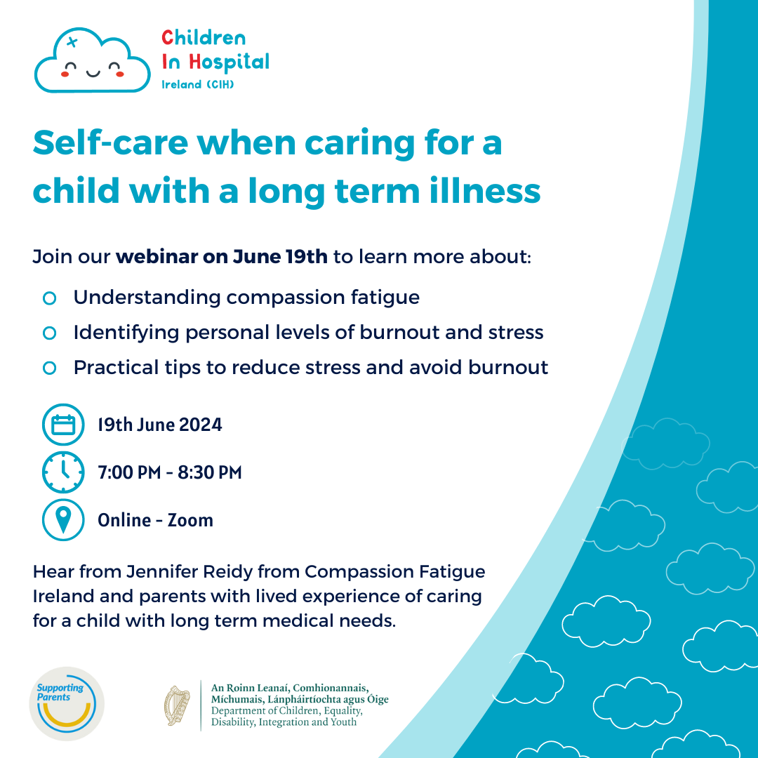
Would you like to learn more about self-care and avoiding burnout when caring for a child with a long-term illness?

Register for the Children In Hospital Ireland webinar on June 19th!

https://informationhub.childreninhospital.ie/webinars-and-events/

Post 6
Safe Harbour – Book for Bereaved Children
Event Date: N/A
Post Date: 27/06/2024

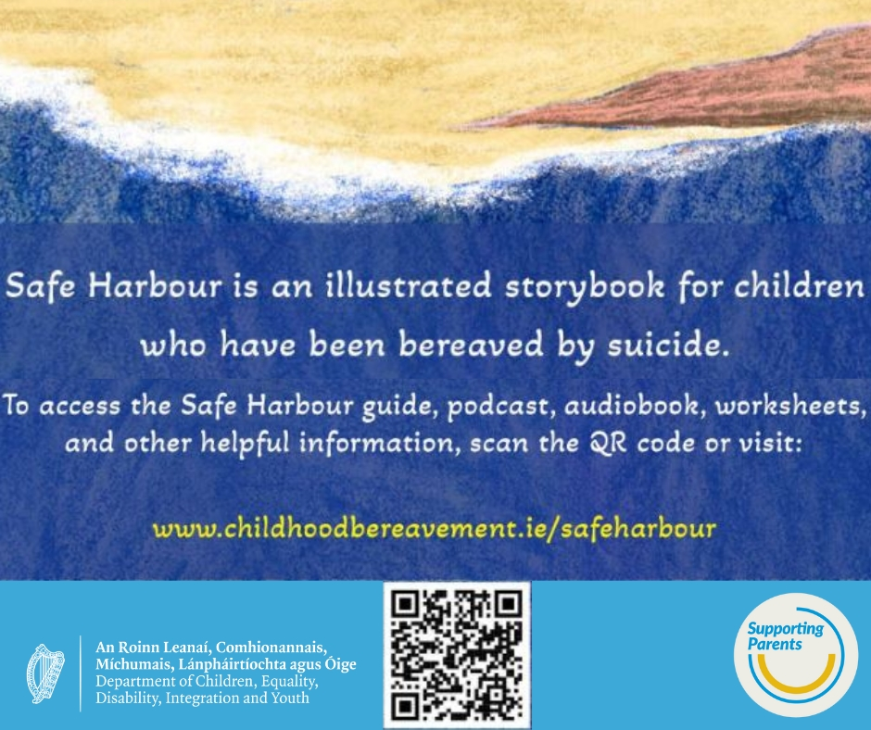

Safe Harbour is an illustrated storybook for children who have been bereaved by suicide

It comes with a guide that will help parents and carers to read Safe Harbour with their child & empower them to have these difficult conversations

Free at QR Code/link

#SupportingParentsIre

Post 7
South West Wexford Family Resource Centre Events
Event Date: Starting in July
Post Date: 28/06/2024

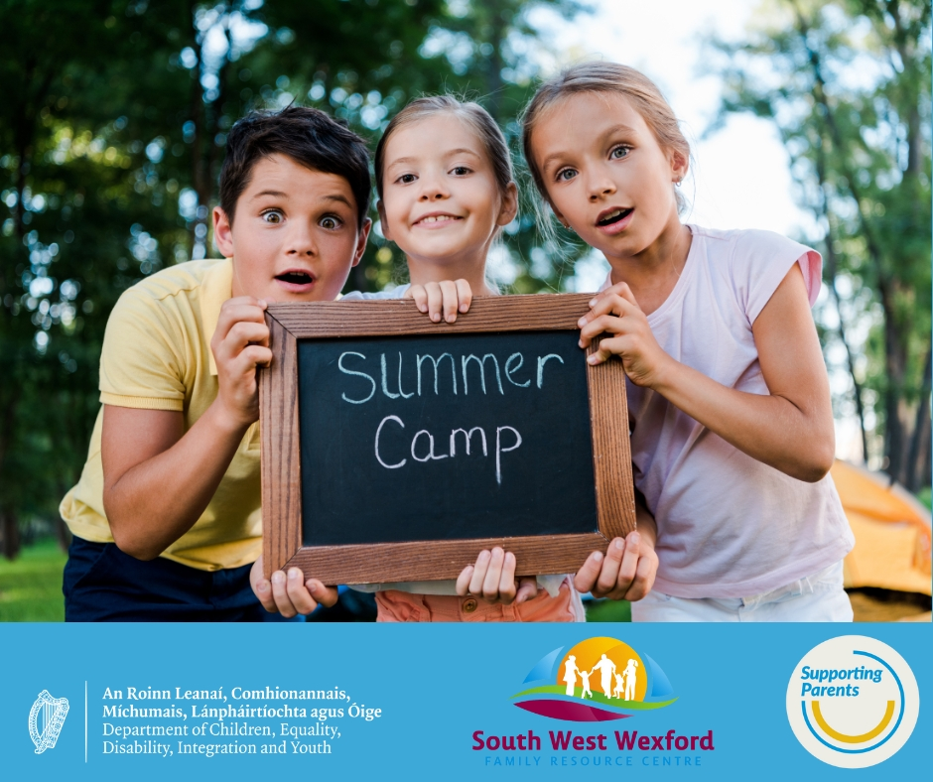

This July, South West Wexford Family Resource Centre are running Childcare Camps for children aged 3-12 as well as events for children and young people aged 9-18.
Get in touch at reception@swwfcr.ie or check out https://www.facebook.com/swwfrc/ for details

#SupportingParentsIre

