Greenshill

Kilkenny

R95 YYC0

Tel: 086 1746330

Email: recoverycollegesoutheast@gmail.com

Website: www.recoverycollegesoutheast.com

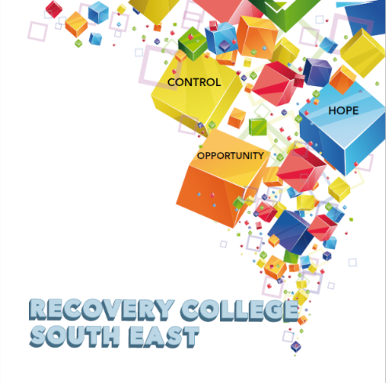

+

|  |  |  |  |
| --- | --- | --- | --- |
| **Recovery Education Programme – Kilkenny**  **September - December 2024**  **You are invited to join us in our new Recovery Education Programme for Autumn/Winter 2024.**  *All our courses and workshops are co-produced and co-delivered by those who have lived experience in partnership with professional expertise, “****the expert by experience working alongside the expert by profession”****.*  *Courses and workshops at the Recovery College South East are for everyone and are free.*  **C:\Users\MY PC\Documents\Calendar Jan to April 2023\qrcode_www.recoverycollegesoutheast.com Jan-April 2023.png(For more detailed information on the workshops, please go to the Workshop Section of our Website –** [www.recoverycollegesoutheast.com](http://www.recoverycollegesoutheast.com).) **You can scan our QR code for quick access to our website**   1. **Complete the attached enrolment form and email it to the Recovery College South East at** [**enrolrecoverycollegesoutheast@gmail.com**](mailto:enrolrecoverycollegesoutheast@gmail.com) **or** 2. **Phone us on 086 1746330 to enrol** | | | |
| **September/October 2024** | | | |
| **VENUE** | **WORKSHOP NAME** | **DATES** | **TIME** |
|  |  |  |  |
| **Recovery College South East**  **Kilkenny** | **Gardening for Wellbeing (Every Monday)**  Are you interested in learning how you can improve your overall wellbeing through gardening and connecting with others? If so, why not become of a social gardening group, with a relaxed, friendly, fun atmosphere. No experience required. | Starting Monday 16th September | 10am – 12pm |
| **Recovery College South East**  (In-house and Online) | **Writing Group**  This group is open to anyone, regardless of whether you are an experienced writer, a beginner or even just curious about creative writing. So, come along, join the group and give it a go. Looking forward to meeting you. | Every Tuesday starting 17th September | 3pm – 4pm |
| Recovery College South East,  Kilkenny | **Dealing with Worry (Morning workshop)**  Worry is a normal emotion; everyone worries to some degree. There is no right or wrong amount of worry. However, worry becomes a problem when it gets in the way of you doing what you want to do, affects your day-to-day life, takes over and becomes overwhelming.  This workshop will give you the practical tools to help you manage worries. | Thursday 19th September | 10.00am - 12.30pm |
| **Involvement Centre, Kilkenny**  **R95 YYCO**  (In-house only) | **Much more than words**  “Much more than words” – a space where you can share a poem, tell a short story, write a few words, sing a song, draw a picture or just sit, listen and enjoy. Open to everyone, it’s fun, entertaining and a great way to meet people – a good way to express yourself and what may be going on for you in your world. Come along and give it a go! | Every Friday | 11am – 12pm |
| **Involvement Centre**  **Carlow**  (In-house only) | **Much more than words**  “Much more than words” – a space where you can share a poem, tell a short story, write a few words, sing a song, draw a picture or just sit, listen and enjoy. Open to everyone, it’s fun, entertaining and a great way to meet people – a good way to express yourself and what may be going on for you in your world. Come along and give it a go! | Every Friday | 11.30am – 12.30pm |
| **Recovery College South East,**  **Kilkenny** | **Feel The Fear (4-week workshop – one morning per week)**  Everyone has fears, they run through our lives. This 4-week workshop, based on the book by Susan Jeffers, shows us how to break down our fears, and work through our fears to a resolution. As she says, “Feel the Fear and do it anyway.” | Thursday 26th September and 3rd, 10th and 17th October | 10.00am - 12.30pm |
| **November/December 2024** | | | |
| **Recovery College South East,**  **Kilkenny** | **Mind Over Mood (6-week workshop – one morning per week)**  Change the way you feel by changing the way you think. This 6-week workshop is an interactive programme based on a cognitive behavioural Therapy (CBT) approach aimed at improving mood and is particularly suitable for those experiencing anxiety and/or depression. The aim of this series of workshops is to:   * Learn how your thoughts, emotions, physical feelings, behaviours, and life situations are all interconnected and affect each other * Identify and challenge unhelpful thoughts and beliefs, and develop more helpful and balanced ways of thinking * Identify and change aspects of your behaviour that may be perpetuating or worsening your mood * Learn tools, skills and practical steps you can take to make positive changes, to improve your mood and to feel better * Each week builds on the previous week, so it is advised to attend all of the weeks if possible.  Home practice exercises will be suggested for in between session practices. | Thursday  7th, 14th, 21st and 28th November, and 5th and 12th December | 10.00am - 12.30pm |