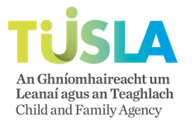

Child & Youth Participation Training

Community & Voluntary Application Form

Please complete all details below and return to[**maurice.oharalyons@tusla.ie**](mailto:maurice.oharalyons@tusla.ie)

**Spring Training Dates:**

* Module 1: E-learning;
* Module 2: Feb 11th (10am-1.30pm) MS-TEAMS
* Module 3: March 25th (10am-12.30pm) MS-TEAMS

|  |  |  |  |  |
| --- | --- | --- | --- | --- |
| Name | Organisation | Email Address | Phone Number | CFSC Coordinator |
|  |  |  |  |  |

**Workforce Learning & Workforce Development**